How to Configure DHCP Server on CentOS/RHEL 7/6/5

DHCP ([Dynamic Host Configuration Protocol](https://tecadmin.net/what-is-dhcp-server/)) is a network protocol used for assigning IP address to network clients dynamically from a predefined IP pool. It is useful for LAN network, but not generally used for production servers. This article will help you for Configuring DHCP Server on CentOS, Red Hat System. Read more about dhcp [here](https://tecadmin.net/what-is-dhcp-server/).

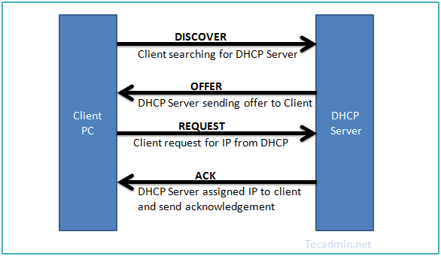

**Install DHCP Package**

First install DHCP packages using yum package manager on CentOS, Red Hat systems. DHCP rpms are available under base repositories, so we don’t need to add an extra repository.

yum install dhcp

**Update /etc/sysconfig/dhcpd File**

Firstly we need to set ethernet interface name as DHCPDARGS in **/etc/sysconfig/dhcpd** file. Edit this configuration file and update the ethernet name.

DHCPDARGS=eth1

**Configure DHCP Server**

DHCP creates an empty configuration file **/etc/dhcp/dhcpd.conf**. Also it provides a sample configuration file at **/usr/share/doc/dhcp*/dhcpd.conf.sample**, which is very useful for configuring the DHCP server.

So as a first part, copy the content of sample configuration file to the main configuration file. Sample configuration file may be changed as perversion you have installed on your system.

# cp /usr/share/doc/dhcp-4.1.1/dhcpd.conf.sample /etc/dhcp/dhcpd.conf

**3.1 – Parameter Configuration**

First configure the basic options which is common to all supported networks.

option domain-name "tecadmin.net";

option domain-name-servers ns1.tecadmin.net, ns2.tecadmin.net;

default-lease-time 600;

max-lease-time 7200;

authoritative;

log-facility local7;

**3.2 – IP Subnet Declaration**

First, edit DHCP configuration file and update subnet details as per your network. For this example we are configuring DHCP for **192.168.1.0/24** LAN network.

subnet 192.168.1.0 netmask 255.255.255.0 {

option routers 192.168.1.254;

option subnet-mask 255.255.255.0;

option domain-search "tecadmin.net";

option domain-name-servers 192.168.1.1;

option time-offset -18000; # Eastern Standard Time

range 192.168.1.10 192.168.1.100;

}

**3.3 -Assign Static IP Address to Host**

In some cases, we need to assign a fixed IP to an interface each time it requested from dhcp. We can also assign a fixed IP on basis of MAC address (hardware ethernet) of that interface. Setup host-name is optional to set up.

host station1 {

option host-name "station1.example.com";

hardware ethernet 00:11:1A:2B:3C:AB;

fixed-address 192.168.1.100;

}

**Start DHCP Service**

After making all above changes, let’s start dhcp service using following commands as per your operating system version.

For CentOS/RHEL 7

systemctl start dhcp

For CentOS/RHEL 6/5

service dhcp start

Similarly to stop and restart dhcp service use following commands.

For CentOS/RHEL 7

systemctl stop dhcp

systemctl restart dhcp

For CentOS/RHEL 6/5

service dhcp stop

service dhcp restart

**Step 5: Setup Client System**

At this stage we have a running dhcp server which is ready for accepting requests and assign them a proper ip. but to verify I have another CentOS machine running on same LAN. Now login to that client machine and edit Ethernet configuration file.

vim /etc/sysconfig/network-scripts/ifcfg-eth1

DEVICE=eth1

BOOTPROTO=dhcp

TYPE=Ethernet

ONBOOT=yes

Make sure **BOOTPROTO** is set to **dhcp**.

Let’s restart network services on the client machine. You will get that dhcp server assigned an ip address from the defined subnet. If you have connected to client pc from remote login, Your session can be disconnected.

For CentOS/RHEL 7

systemctl restart network

For CentOS/RHEL 6/5

service network restart